Report
In a page when there is not a lot of information leave more space (standard spacing) between sections for
- Risk Cockpit & Attention and Escalated Risks (Everything sequentially at the top of the page in pdf and ppt) nok in pdf and in ppt
- Decision Cockpit & Attention, Decision Queue and Recent Decision outcomes (it is spread across the page in ppt and not in pdf) Ok solved in ppt, nok in pdf
The following looks good
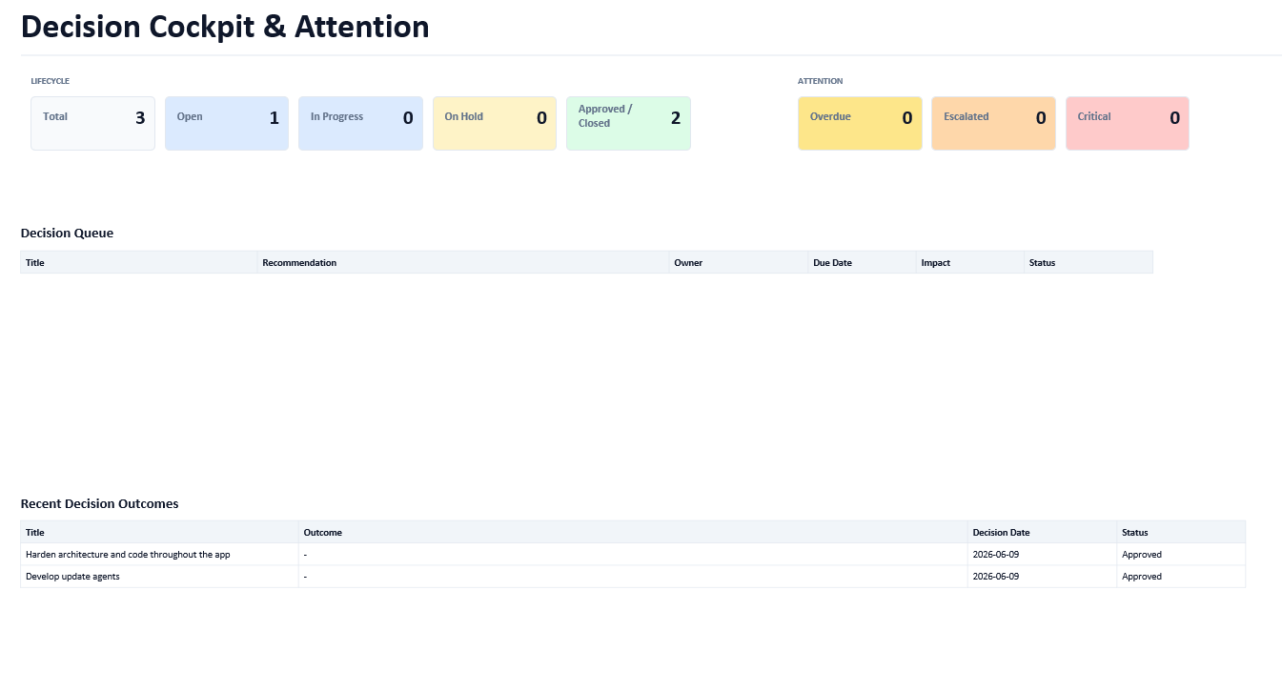
The following looks bad /there should be separation between Risk Cockpit & attention and Escalated Risks if the whole page is blank.
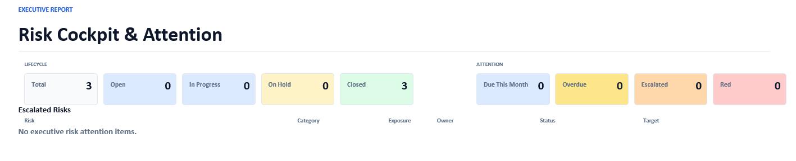

In the new One page Executive Briefing

We should be able to include this Briefing in the PPt and Pdf reports and also create a pdf and ppt with only this overview. The Print works in ppt and pdf.
The output is bad because timeline and sections overlap, and the content is empty.

Pdf result
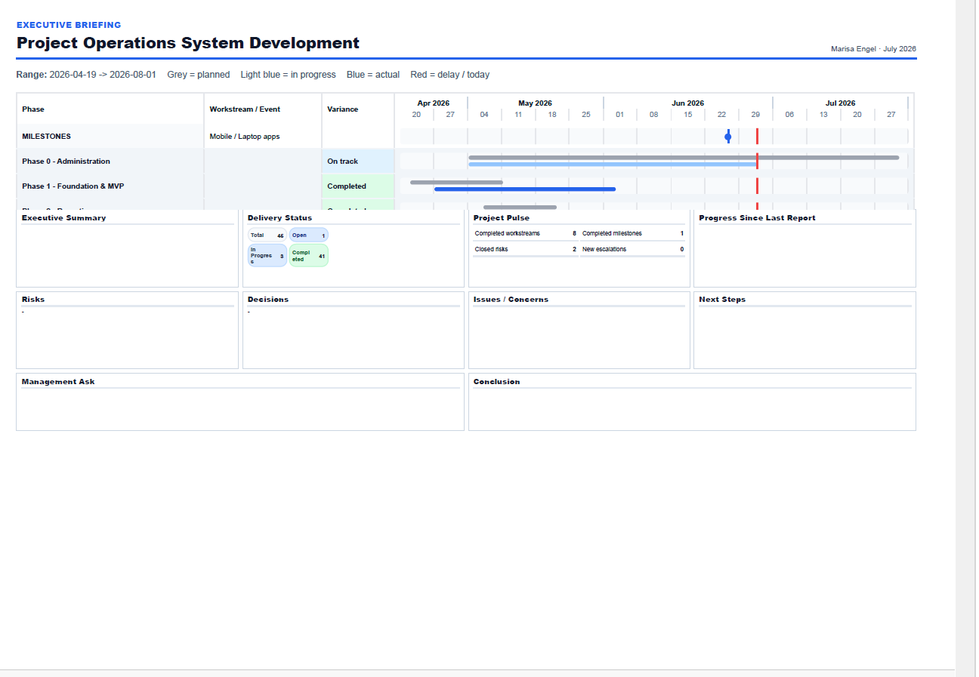

PPt result is even worst the Gantt appears as a sequence of text, all boxes are empty and occupying the whole page.
